Performance optimization
Aim
Measure and improve page, report and workflow performance with selective queries and bounded processing.
Procedure
- Create a synthetic dataset within plan limits (e.g. 200 requests, 20 technicians, 8 bays); record actual sizes.
- Measure the command center page, Active_Requests report and search repeatedly: one warm-up, then at least ten timings; report median and range.
- Replace full-table loops with criteria-based fetches; call APIs outside loops.
- Limit initial report rows and columns; load heavy content only where needed (Board shows active statuses only).
- Change one thing at a time and re-measure; confirm totals and permissions are unchanged. Do not claim access to arbitrary database indexes.

Application images and explanation
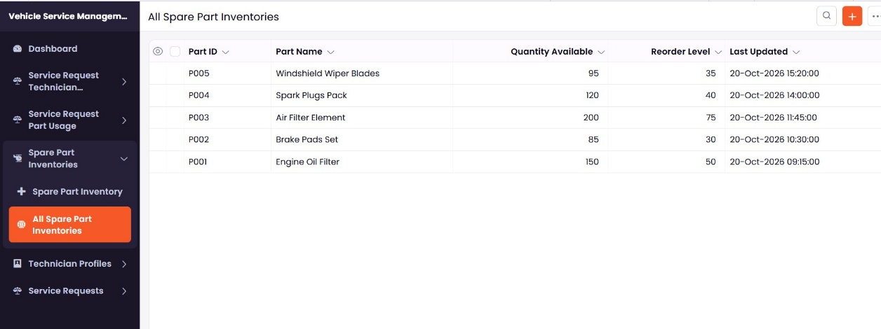
All Spare Part Inventories report used as a performance test surface
Screenshot from the application.

Process diagram
MEASURE A BASELINE
Same dataset, role and device
CHANGE ONE BOTTLENECK
Criteria, bounded rows, fewer calls
REPEAT AND RECONCILE
Compare timings and results

Generated explanatory diagram. It is not a screenshot of an executed workflow.

Result
Expected result and verification criteria. Improvements are reported with test conditions and unchanged results; no guarantee is inferred from a small dataset.

